# [Law & Order: SVU fans outraged over Kelli Giddish’s firing and beg show to ‘rehire Rollins’ after ‘incredible’ episode](https://www.the-sun.com/entertainment/6390494/law-order-svu-kelli-giddish-firing-rollins-incredible-episode/)

* [**Rachael Ellenbogen**](https://www.the-sun.com/author/rachael-ellenbogen/)
* 14:52 ET, Oct 7 2022

**THE latest Law & Order: SVU episode has caused even more outrage among fans over star Kelli Giddish’s firing.**

Viewers are preparing to say goodbye to the star's character, Det. Amanda Rollins, but Thursday's new episode is making that harder to do.

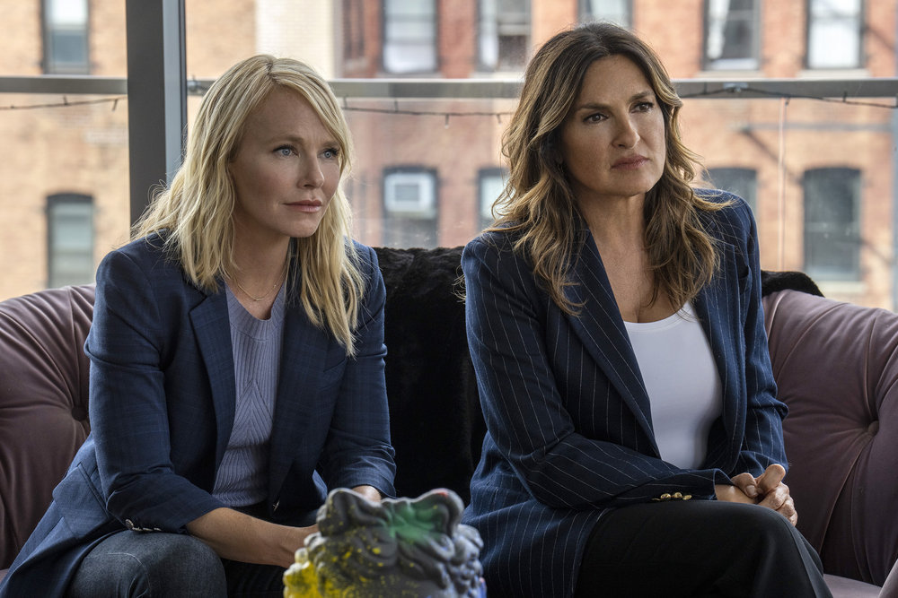

4

**Law and Order fans are still furious over Kelli Giddish's firing**Credit: Zach Dilgard/NBC

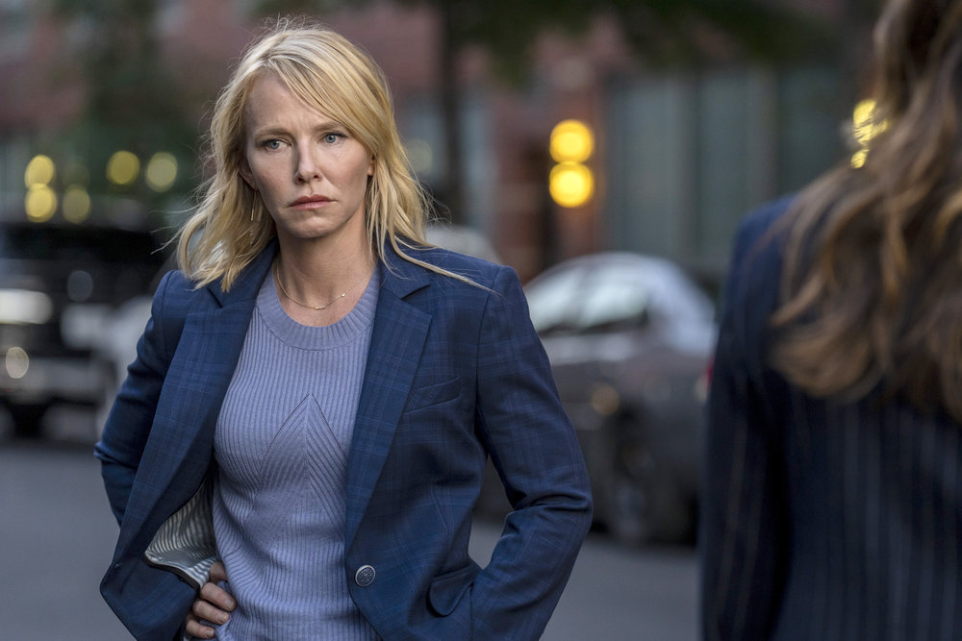

4

**Her being let go from the series was announced in August, and this is her final season as Det. Amanda Rollins**Credit: Zach Dilgard/NBC

In August, Kelli announced on Instagram that this would be her final season on [SVU](https://www.the-sun.com/topic/law-order-svu/), with it later coming out that she was let go from the long-running show.

This week, fans were treated to a Rollins-centric episode after the character was recently shot.

The emotional showing featured the detective dealing with PTSD from the incident, and fans praised Kelli for her acting while slamming the show for firing her.

One upset viewer tweeted: “How do you make a #Rollins based episode and think fans wouldn’t care or be unhappy that y’all fired Kelli?????”

### READ MORE ON LAW & ORDER

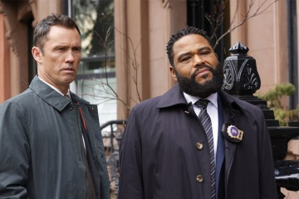

[**NEW ORDER**](https://www.the-sun.com/entertainment/6339213/law-order-anthony-anderson-leaving-cast-replacement-mehcad-brooks/)

### [**Law & Order fans divided after Anthony Anderson exits & ‘replacement’ takes over**](https://www.the-sun.com/entertainment/6339213/law-order-anthony-anderson-leaving-cast-replacement-mehcad-brooks/)

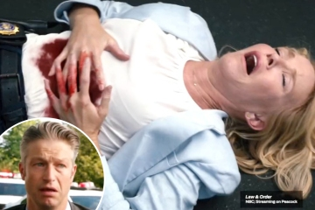

[**OUT OF LINE!**](https://www.the-sun.com/entertainment/6315477/law-and-order-svu-rollisi-scene-cut-deleted-premiere/)

### [**Law and Order fans furious after NBC cuts out ‘important Rollisi scene’**](https://www.the-sun.com/entertainment/6315477/law-and-order-svu-rollisi-scene-cut-deleted-premiere/)

Another wrote: “Oh Rollins...you do this well. SVU needs you. Will miss you every episode!”

A third shared: “I haven’t been this upset and angry about an actress being fired since #StanaKatic got fired from #Castle.”

They then begged: “@WolfEnt @nbc and @lawandordertv stop the madness and just rehire @KelliGiddish on #SVU. We don’t want another actress. We want Kelli!”

A fourth insisted: “I’ll really miss Rollins when she leaves. I’m dreading it and hope her exit isn’t by death.

### MOST READ IN ENTERTAINMENT

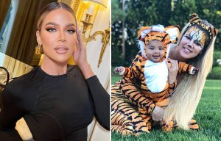

[**WOAH KHLO!**](https://www.the-sun.com/entertainment/6391390/kardashian-fans-shocked-nanny-posts-never-before-seen-photo/)

## [**Khloe fans are shocked after her nanny posts never-before-seen photo of star**](https://www.the-sun.com/entertainment/6391390/kardashian-fans-shocked-nanny-posts-never-before-seen-photo/)



[**ICON GONE**](https://www.the-sun.com/entertainment/6387256/judy-tenuta-dead-comedian-love-goddess-aphrodite-accordion-cancer/)

## [**Famed comedian and actress dies after health battle as tributes pour in**](https://www.the-sun.com/entertainment/6387256/judy-tenuta-dead-comedian-love-goddess-aphrodite-accordion-cancer/)

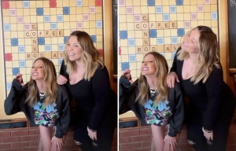

[**BUMP ALERT?**](https://www.the-sun.com/entertainment/6384674/teen-mom-kailyn-lowry-curves-rumors-pregnant-child/)

## [**Teen Mom Kailyn shows off curves in a tight top she's pregnant with fifth baby**](https://www.the-sun.com/entertainment/6384674/teen-mom-kailyn-lowry-curves-rumors-pregnant-child/)



[**TV QUEEN**](https://www.the-sun.com/entertainment/6381593/the-view-moderator-whoopi-goldberg-rips-cohost-stealing-moment/)

## [**The View's Whoopi rips into co-host for stealing her moment in awkward exchange**](https://www.the-sun.com/entertainment/6381593/the-view-moderator-whoopi-goldberg-rips-cohost-stealing-moment/)

“YOU CANT DO THAT TO CARISI, I will sob if this happens.”

While revealing her departure back in August, the Law & Order star wrote: “I wanted to address the chatter I’ve seen online and let everyone know that this will, indeed, be my last season on ‘Law & Order: SVU.’

“Playing Rollins has been one of the greatest joys and privileges of my life. I’ve been so fortunate to be a part of the ‘Law & Order’ family for the last 12 years.

“There is simply no other character on TV like Rollins. She’s grown and changed, and I have as well.”

Kelli continued: “I started on this show when I was in my late 20s and I’m grateful I got to spend so many of my adult years with Rollins in my life.

“I want to thank Dick Wolf, Mariska Hargitay, Warren Leight, Peter Jankowski, NBC, Universal Television, all of my co-stars, every single member on the crew and all the writers here for our incredible work together these last 12 years.

“I’m so excited to take all the things I have learned in my time on ‘SVU’ and put them toward everything that’s next to come.”

Shortly after the announcement, it was revealed that her departure from Law and Order was not her choice.

Multiple sources told [Variety](https://variety.com/2022/tv/news/why-is-kelli-giddish-leaving-law-and-order-svu-1235350955/) that the decision wasn’t made by showrunner David Graziano but instead by higher-ups.

The insiders told the outlet that the company’s desire to keep SVU as current and fresh as possible played a role in the decision, as did contract negotiations involving salary.

Fans immediately became furious over the news, as Kelli has been with the show since 2011, and viewers didn’t want to see her go – especially when it's not on her own terms.

To make matters worse for fans of Kelli's character, Peacock recently [cut a Rollisi – Rollins and boyfriend Carisi – scene](https://www.the-sun.com/entertainment/6315477/law-and-order-svu-rollisi-scene-cut-deleted-premiere/) from the streaming version of the franchise's big crossover event last month.

NBC held a huge, three-show crossover event for its Law and Order franchise for premiere week, with the original series, SVU, and [Organized Crime](https://www.the-sun.com/entertainment/tv/2626493/cast-of-law-and-order-organized-crime/) all taking part.

In the version that originally aired, Rollins' boyfriend Carisi quickly arrived at the scene where his girlfriend had been shot.

With an injured Rollins already sent away in an ambulance, Carisi stood there scared over how this all might end for the woman he loves.

Mariska Hargitay’s Olivia Benson tried to console him and give him hope, telling him: “Amanda is a very strong woman. And if anyone can survive a gunshot wound, we both know that she can.”

“You’re right, you’re right,” he said, before fully starting to cry, leading Benson to hug him during the heartbreaking scene.

Though the scene was short, it was an emotional one featuring characters fans love and about a relationship fans love, which is why viewers were furious after it was cut from the streaming version.

### READ MORE ON THE US SUN

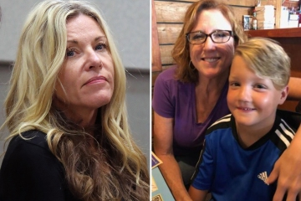

[**'WHERE'S THE JUSTICE?'**](https://www.the-sun.com/news/6387312/lori-vallow-update-jj-grandma-trial-delay-furious-cult/)

### [**Lori Vallow blasted for 'playing games' as case takes shock turn**](https://www.the-sun.com/news/6387312/lori-vallow-update-jj-grandma-trial-delay-furious-cult/)



[**ICON GONE**](https://www.the-sun.com/entertainment/6387256/judy-tenuta-dead-comedian-love-goddess-aphrodite-accordion-cancer/)

### [**Famed comedian and actress dies after health battle as tributes pour in**](https://www.the-sun.com/entertainment/6387256/judy-tenuta-dead-comedian-love-goddess-aphrodite-accordion-cancer/)

An insider told [TVLine](https://tvline.com/2022/09/26/law-order-crossover-rollisi-scene-cut-missing-peacock-streaming/) that the portion of the scene was deleted in order to make the episode a bit shorter for both streaming and syndication.

This would help make room for a short recap at the start of the episode, as this was part of a crossover event and not a normal standalone episode.

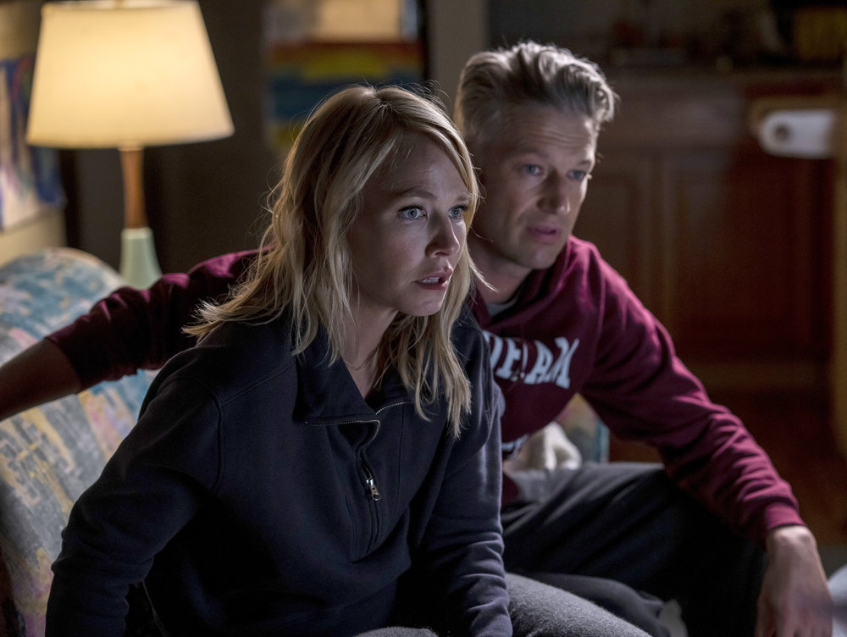

4

**Fans praised Kelli over her 'incredible' acting in Thursday's new episode, and they're now begging the show to 'rehire' her**Credit: Zach Dilgard/NBC

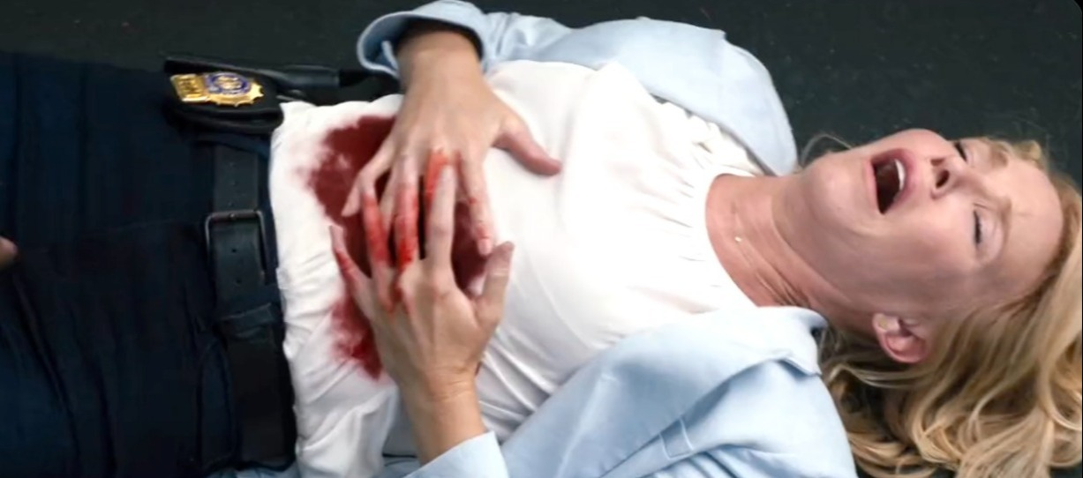

4

**Her character, Rollins, had an emotional episode dealing with PTSD from being shot**Credit: NBC